**SSN COLLEGE OF ENGINEERING**

**DEPARTMENT OF COMPUTER SCIENCE AND ENGINEERING**

**UCS1711 - Mobile Application Development Lab**

**Exercise – 8 SMS Sending and Notification**

Name : Nachammai Devi Pooja S

Reg : 185001096

Date : 13/10/2021

**AIM:**

To develop an android app that sends SMS and creates an alert upon receiving the SMS

**CODE:**

**activity_main.xml:**

| <?xml version="1.0" encoding="utf-8"?> <androidx.constraintlayout.widget.ConstraintLayout xmlns:android="http://schemas.android.com/apk/res/android"  xmlns:app="http://schemas.android.com/apk/res-auto"  xmlns:tools="http://schemas.android.com/tools"  android:layout_width="match_parent"  android:layout_height="match_parent"  tools:context=".MainActivity">   <TextView  android:id="@+id/textView2"  android:layout_width="wrap_content"  android:layout_height="wrap_content"  android:text="SMS App"  android:textAppearance="@style/TextAppearance.AppCompat.Display1"  android:textColor="#067A6A"  app:layout_constraintBottom_toBottomOf="parent"  app:layout_constraintLeft_toLeftOf="parent"  app:layout_constraintRight_toRightOf="parent"  app:layout_constraintTop_toTopOf="parent"  app:layout_constraintVertical_bias="0.096" />   <TextView  android:id="@+id/textView"  android:layout_width="wrap_content"  android:layout_height="wrap_content"  android:layout_marginTop="28dp"  android:layout_marginEnd="140dp"  android:text="Send an SMS"  android:textAppearance="@style/TextAppearance.AppCompat.Large"  android:textColor="#0C675A"  app:layout_constraintEnd_toEndOf="parent"  app:layout_constraintTop_toBottomOf="@+id/textView2" />   <TextView  android:id="@+id/phno"  android:layout_width="wrap_content"  android:layout_height="wrap_content"  android:layout_marginStart="44dp"  android:layout_marginTop="44dp"  android:text="Phone Number:"  android:textAppearance="@style/TextAppearance.AppCompat.Medium"  android:textColor="#304FFE"  app:layout_constraintStart_toStartOf="parent"  app:layout_constraintTop_toBottomOf="@+id/textView" />   <TextView  android:id="@+id/smstv"  android:layout_width="wrap_content"  android:layout_height="wrap_content"  android:layout_marginStart="44dp"  android:layout_marginTop="104dp"  android:text="SMS Content:"  android:textAppearance="@style/TextAppearance.AppCompat.Medium"  android:textColor="#304FFE"  app:layout_constraintStart_toStartOf="parent"  app:layout_constraintTop_toBottomOf="@+id/textView" />   <EditText  android:id="@+id/etPhone"  android:layout_width="199dp"  android:layout_height="39dp"  android:layout_marginStart="12dp"  android:layout_marginTop="36dp"  android:ems="10"  android:inputType="phone"  android:textAppearance="@style/TextAppearance.AppCompat.Body1"  app:layout_constraintStart_toEndOf="@+id/phno"  app:layout_constraintTop_toBottomOf="@+id/textView" />   <EditText  android:id="@+id/content"  android:layout_width="341dp"  android:layout_height="123dp"  android:layout_marginTop="68dp"  android:layout_marginEnd="32dp"  android:ems="10"  android:gravity="start|top"  android:hint="Type here"  android:inputType="textMultiLine"  android:textAppearance="@style/TextAppearance.AppCompat.Body1"  app:layout_constraintEnd_toEndOf="parent"  app:layout_constraintTop_toBottomOf="@+id/etPhone" />   <Button  android:id="@+id/sendbtn"  android:layout_width="wrap_content"  android:layout_height="wrap_content"  android:layout_marginTop="48dp"  android:layout_marginEnd="160dp"  android:backgroundTint="#00BFA5"  android:text="SEND"  app:layout_constraintEnd_toEndOf="parent"  app:layout_constraintTop_toBottomOf="@+id/content" />  </androidx.constraintlayout.widget.ConstraintLayout> |
| --- |

**MainActivity.java:**

| package com.example.ex8;  import androidx.appcompat.app.AppCompatActivity; import androidx.core.app.ActivityCompat; import androidx.core.content.ContextCompat;  import android.Manifest; import android.content.BroadcastReceiver; import android.content.Context; import android.content.Intent; import android.content.pm.PackageManager; import android.os.Bundle; import android.telephony.SmsManager; import android.telephony.SmsMessage; import android.view.View; import android.widget.Button; import android.widget.EditText; import android.widget.Toast;  public class MainActivity extends AppCompatActivity {   private static final int MY_PERMISSIONS_REQUEST_SEND_SMS = 0;  Button sendBtn;  EditText txtphoneNo;  EditText txtMessage;  String phoneNo;  String message;    @Override  protected void onCreate(Bundle savedInstanceState) {  super.onCreate(savedInstanceState);  setContentView(R.layout.activity_main);   sendBtn = (Button) findViewById(R.id.sendbtn);  txtphoneNo = (EditText) findViewById(R.id.etPhone);  txtMessage = (EditText) findViewById(R.id.content);   sendBtn.setOnClickListener(new View.OnClickListener() {  public void onClick(View view) {  if (ActivityCompat.checkSelfPermission(MainActivity.this, Manifest.permission.SEND_SMS) == PackageManager.PERMISSION_GRANTED) {  try {  SmsManager smsManager = SmsManager.getDefault();  smsManager.sendTextMessage(txtphoneNo.getText().toString(), null, txtMessage.getText().toString(), null, null);  Toast.makeText(MainActivity.this, "SMS Sent!", Toast.LENGTH_LONG).show();  } catch (Exception e) {  Toast.makeText(MainActivity.this, "Error!", Toast.LENGTH_LONG).show();  }  } else {  ActivityCompat.requestPermissions(MainActivity.this, new String[]{Manifest.permission.SEND_SMS}, 0);  }  }  });  }  } |
| --- |

**SMSReceiver.java:**

| package com.example.ex8;  import android.content.BroadcastReceiver; import android.content.Context; import android.content.Intent; import android.telephony.SmsMessage; import android.util.Log; import android.widget.Toast;   public class SMSReceiver extends BroadcastReceiver {  public static final String ACTION ="android.provider.Telephony.SMS_RECEIVED";  private static final String SMS_SENDER="123456789";   @Override  public void onReceive(Context context, Intent intent) {  if (intent != null && intent.getAction() != null &&  ACTION.compareToIgnoreCase(intent.getAction()) == 0) {  Object[] pduArray = (Object[]) intent.getExtras().get("pdus");  SmsMessage[] messages = new SmsMessage[pduArray.length];  for (int i = 0; i < pduArray.length; i++) {  messages[i] = SmsMessage.createFromPdu((byte[]) pduArray[i]);  }   String sms_from = messages[0].getDisplayOriginatingAddress();   if (sms_from.equalsIgnoreCase(SMS_SENDER)) {  StringBuilder bodyText = new StringBuilder();   for (int i = 0; i < messages.length; i++) {  bodyText.append(messages[i].getMessageBody());  }  //SMS Body  String body = bodyText.toString();  // Lets get SMS Code  String code = body.replaceAll("[^0-9]", "");    String senderNum = SMS_SENDER;   Log.i("SmsReceiver", "senderNum: "+ senderNum + "; message: " + body);   // Show Alert  int duration = Toast.LENGTH_LONG;  Toast toast = Toast.makeText(context,  "senderNum: "+ senderNum + ", message: " + body, duration);  toast.show();  }  }  }  } |
| --- |

**AndroidManifest.xml:**

| <?xml version="1.0" encoding="utf-8"?> <**manifest** xmlns:android="http://schemas.android.com/apk/res/android"  package="com.example.ex8">   <**uses-permission** android:name="android.permission.SEND_SMS" />  <**uses-permission** android:name="android.permission.RECEIVE_SMS" />   <**application**  android:allowBackup="true"  android:icon="@mipmap/ic_launcher"  android:label="@string/app_name"  android:roundIcon="@mipmap/ic_launcher_round"  android:supportsRtl="true"  android:theme="@style/Theme.Ex8">   <**activity**  android:name=".MainActivity"  android:exported="true">  <**intent-filter**>  <**action** android:name="android.intent.action.MAIN" />   <**category** android:name="android.intent.category.LAUNCHER" />  </**intent-filter**>  </**activity**>  </**application**>  </**manifest**> |
| --- |

**OUTPUT:**

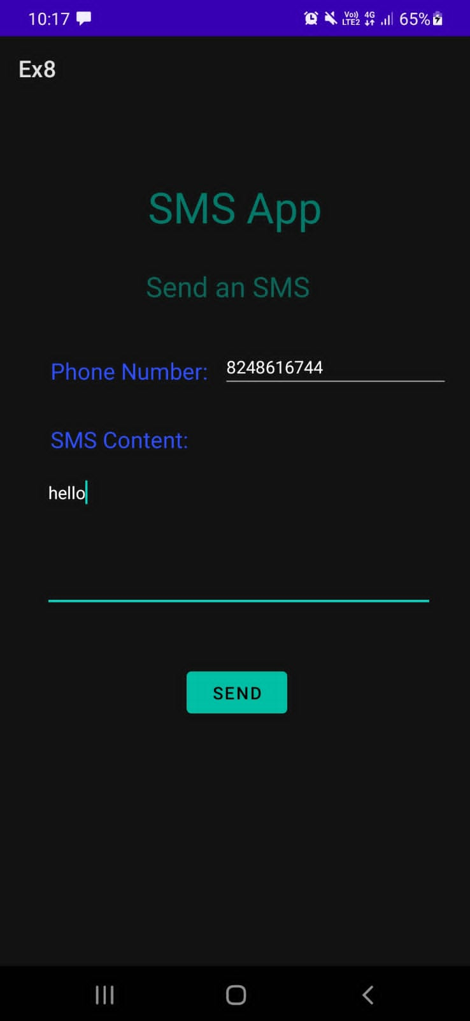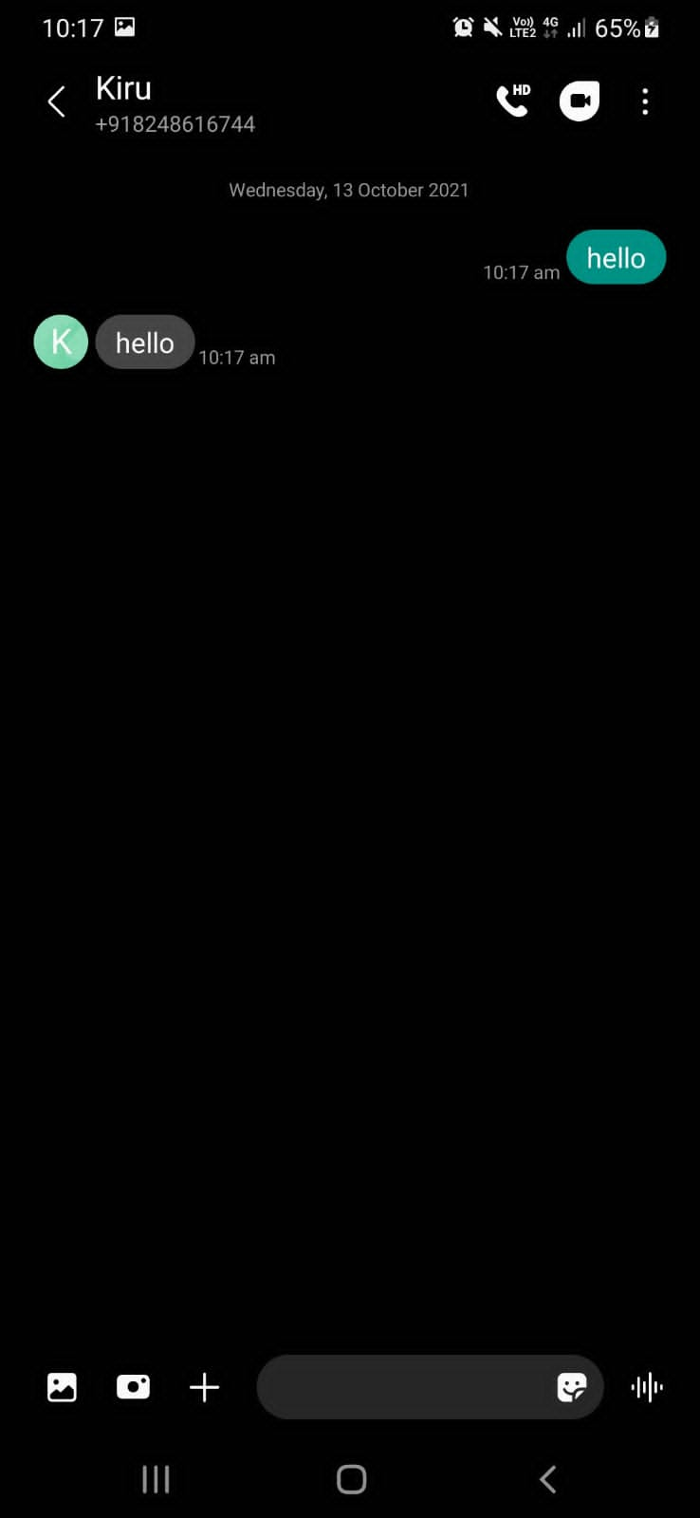

**RESULT:**

Successfully developed an android app that sends SMS and creates an alert upon receiving the SMS.